**ASSIGNMENT 1:** วงจร Music Keypad

**อุปกรณ์**

1. บอร์ด Arduino UNO R3 X 1
2. Buzzer X 1
3. 4 X 4 Keypad X 1
4. สายไฟ X 8

**ลักษณะวงจร**

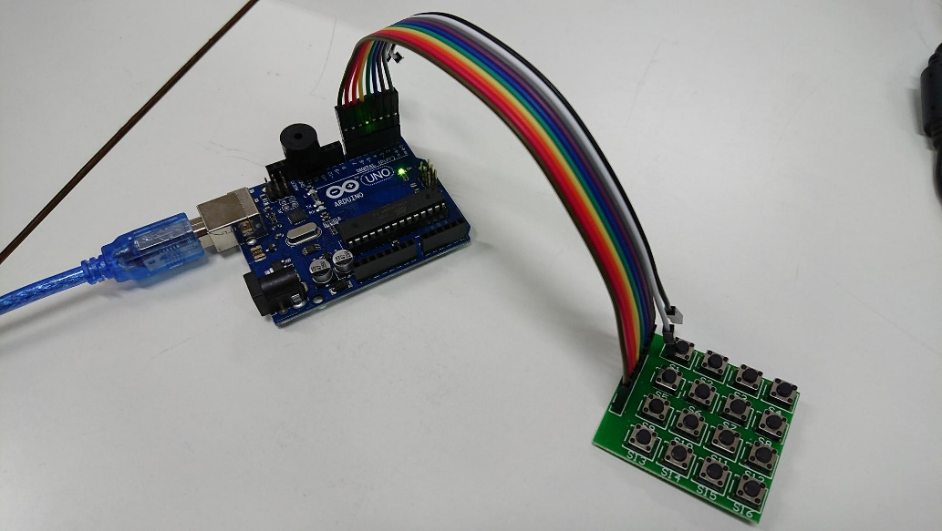

**หลักการทำงานของวงจร**

วงจรรอรับค่าจาก Keypad 4 X 4 แล้วแสดงผลลัพธ์เป็นเสียงที่แตกต่างกันจากปุ่มที่แตกต่างกัน

**โค้ดของวงจร**

.INCLUDE "m328Pdef.inc"

.DEF TMP = r16

.DEF READ_V = r17

.DEF VAR_A = r18

.DEF DISTANCE = r19

.DEF TL = r20

.DEF TA = r21

.DEF TB = r22

.MACRO COMPARE_AND_BRANCH_IF_KEYPRESSED

cpi VAR_A, 0xff

brne KEYPRESSED

.ENDMACRO

.CSEG

.ORG 0x0000

rjmp RESET

RESET:

ldi TMP, 0x28

out DDRB, TMP

ldi TMP, 0x00

out PORTB, TMP

ldi TMP, 0xf0

out DDRD, TMP

READ_KEY_PAD:

;----- row A

ldi TMP, 0b11101111

ldi DISTANCE, 0

call SCAN_KEYPAD

COMPARE_AND_BRANCH_IF_KEYPRESSED

;----- row B

ldi TMP, 0b11011111

ldi DISTANCE, 9

call SCAN_KEYPAD

COMPARE_AND_BRANCH_IF_KEYPRESSED

;----- row C

ldi TMP, 0b10111111

ldi DISTANCE, 18

call SCAN_KEYPAD

COMPARE_AND_BRANCH_IF_KEYPRESSED

;----- row D

ldi TMP, 0b01111111

ldi DISTANCE, 27

call SCAN_KEYPAD

COMPARE_AND_BRANCH_IF_KEYPRESSED

ldi TMP, 0x00

out PORTB, TMP

rjmp READ_KEY_PAD

KEYPRESSED:

call VOL_UP

rjmp READ_KEY_PAD

VOL_UP:

ldi TL, 0x28

out PORTB, TL

rcall _settime

rcall _delay

ldi TL, 0x00

out PORTB, TL

rcall _settime

rcall _delay

ret

_settime:

ldi TA, 0xff

mov TB, VAR_A

ret

_delay:

dec TA

brne _delay

dec TB

brne _delay

ret

SCAN_KEYPAD:

ldi ZL, low(KEYPAD_TABLE*2)

ldi ZH, high(KEYPAD_TABLE*2)

out PORTD, TMP

nop

in READ_V, PIND

ldi TMP, 0x0f

and READ_V, TMP

add READ_V, DISTANCE

subi READ_V, 7

ldi TMP, 0x00

add ZL, READ_V

adc ZH, TMP

lpm VAR_A, Z

ret

KEYPAD_TABLE:

.DB 0x0f, 0xff, 0xff, 0xff, 0x10, 0xff, 0x11, 0x12, 0xff, 0x13, 0xff, 0xff, 0xff, 0x14, 0xff, 0x15, 0x16, 0xff

.DB 0x17, 0xff, 0xff, 0xff, 0x18, 0xff, 0x19, 0x1a, 0xff, 0x1b, 0xff, 0xff, 0xff, 0x1c, 0xff, 0x1d, 0x1e, 0xff